

**Technology Entrepreneurship**

**Assignment No. Two**

01.11.2015

**─**

## Group 7

Adrian Chambers

Robert Gabriel

Michael Mahoney

Karoline Alduino

# PEER REVIEW SHEET

PLEASE FILL IN THIS FORM AND ATTACH TO EACH GROUP ASSIGNMENT WHEN HANDING UP.

## STUDENT CANDIDATE NAME: % * STUDENT CANDIDATE NO:

_____________________________________________________________________

_____________________________________________________________________

_____________________________________________________________________

_____________________________________________________________________

## STUDENT CANDIDATE NAME: % * STUDENT CANDIDATE NO:

_____________________________________________________________________

_____________________________________________________________________

_____________________________________________________________________

_____________________________________________________________________

## STUDENT CANDIDATE NAME: % * STUDENT CANDIDATE NO:

_____________________________________________________________________

_____________________________________________________________________

_____________________________________________________________________

_____________________________________________________________________

## STUDENT CANDIDATE NAME: % * STUDENT CANDIDATE NO:

_____________________________________________________________________

_____________________________________________________________________

_____________________________________________________________________

_____________________________________________________________________

**All group members contributed equally, please circle: Yes / No**

**Date:**

**Signatures:**

# Opportunity Identification & Idea Generation

There have been many cases of businesses failing but this is not necessarily due to the lack of work from the entrepreneur, sometimes there was no real opportunity in the first place. Opportunity identification can be considered as an essential capability of entrepreneurs. Gaglio and Katz claim that “understanding the opportunity identification process represents one of the core intellectual questions for the domain of entrepreneurship”. (<http://link.springer.com/article/10.1023%2FA%3A1011132102464#page-1>).

Idea generation can be defined as the production of ideas for something new. (Entrepreneurship: A Process Perspective By Robert Baron, Scott Shan page 68). There are various techniques used for generating ideas. This section of the report will provide information on the techniques that were applicable to our team during our idea generating sessions:

## Brainstorming

This technique involves a team (or an individual) generating multiple solutions to find a solution to a particular problem. All ideas are considered in a brainstorming session and there have been cases where unrealistic ideas become practical ones, with some adjustments. Some ideas may be combined to create a single solution.( http://www.entrepreneurial-insights.com/brainstorming-techniques-for-idea-generation/)

Since our team consisted of members that are in the tech industry field, we decided to focus on ideas within this area. It was determined that brainstorming would be a good way of allowing each member to express themselves, therefore sharing their thoughts on areas in the sector that they felt could be improved or introduced. This approach was excellent in determining possible opportunities in the sector.

## Problem Areas

An idea generation technique that we took on board was examining the problem areas, not just in our own lives, but in the lives of our friends and families. This is helpful as one may be limiting themselves when they try and only focus on the problems in their own lives. It’s also helpful to bring in ideas from outside the group as they may present a different angle that you may not have thought of otherwise.

A way to go about this is to ask your friends and family about different problems in their lives, no matter how unattainable a solution may be, and compile them into a list. The next step then is to come up with various solutions individually or by brainstorming as a group. Again it’s good practice to submit any solution no matter how unattainable as you can then focus on making them attainable.

## Point-of-View Madlib

Through this idea generation technique, we were able to develop our ideas by using three elements of our points-of-view to create some problem statements: user, need and insight.

With a paper and some post-its, we could try out to design more than one problem statement for each problem that we were trying to solve. Once all the problem statements were on the paper, we chose those which were actionable and then we were able to develop solutions in an easier way.

(http://dschool.stanford.edu/wp-content/themes/dschool/method-cards/point-of-view-madlib.pdf)

# Ideas and Problems

**Adrian’s Ideas:**

Hi Guys here is a few of the ideas that I have been thinking up.

1. **College Cab**

The idea here is that an app is created for students in colleges - how it works -

Students that have cars and are planning on going into the city, blarney, cobh, midelton, etc.. (anywhere really) can alert other students that are using the app (and dont have no cars) and if they need a spin to that location they can agree a fee and off they go.

1. **Bid Delivery**

This idea is similar enough but geared toward a different market.. The idea here is to create an app that allows people get stuff delivered to their house (or location) but in a bidding fashion. I will give an example… Let’s say a mother is at home and has small children in bed and discovers she needs a bottle of milk (or whatever - it can be fast food etc.) since its late and she cant go out she can use the app to see if someone will deliver the product to her.. but lets say 3 people say they can deliver it.. it will work in a bidding fashion she can choose whoever gives the best price.

1. **Trolley Scan**

The idea here is to create a barcode type scanner that attaches to trolleys which allows users to get instant price checks on items that they may want to purchase.

1. **Auto defroster**

Ok this idea is a wild one and technically not to much to do with IT, but sounds like a good idea. As you know winter is coming (lol, sound like game of thrones) and Cars always freeze over in the mornings.. the idea is to create sensors that attach to the windows and once a certain temp is reached, the attachments on the windows heat up and prevent the car from freezing over. Since we dont want the battery of the car to get drained we will use solar power to hold the charge for when the attachments need to provide some heat.

## Robert Gabriel Idea’s

### Helper Bird Dyslexia App,

HelperBird changes the font of the website to OpenDyslexic. You can switch it on and off. You can change the size of the font as well

Helper Bird is an extension that overrides all fonts on web page with the award winning OpenDyslexic font and changes the page to be more easily read. You can switch it on and off at any time. Helping people with dyslexia. You can now change the size of the font!.  
  
Features :   
1: Changes the font on the web page to the award winning OpenDyslexic.  
2: Changes the background colour to make easier to read.  
3: Turn it on and Off at anytime.  
4: Change Font Size

### Yik Yak Meets Notes sharing

Yik Yak is a social media smartphone application. It is available for iOS and Android and it allows people anonymously to create and view "Yaks" within a 5-mile radius.

Instead of comments we do notes and files, pretty cool :).

### Notes Timetable App.

The idea is to create a app which will allow you to record your class timetable, it will allow you to take notes on the right and will allow you to store it in the app. The app will alert you will about the upcoming class and store them in the following format for easier searching Interdisciplinary, 3 PM 4/10/2015.

## Michael’s Ideas:

### Programming Logic Learning Tool

* A very high level learning tool for teaching kids the basics of programming logic without getting into a particular language.
* This idea was inspired by the lack of programming classes in primary schools.
* Also inspired by witnessing the frustration of developers when dealing with client requests. Basically the clients don’t really know what to request in their software as they don’t know basic programming logic; it’s capabilities and limitations.

### Music Collaboration App

* An app that allows musicians/bands to request people to provide a rendition of a custom piece of music on a specific instrument so they can use it in their own track.
* This idea is inspired by my friends who are local, small time musicians.
* They usually create music out of passion rather than as a way to make money. Therefore they can’t really afford to hire someone to play a particular instrument that’s only needed for one track.

## Karoline’s Idea:

**Indoor Navigation**

The idea is to create a mobile app that provides an interactive map for big indoor places (airports, universities, malls, museums...). People could create maps for new places and edit existing maps as well.

It is like the gps system, but for specific places. Furthermore, the app would also show in real time if the place is crowded which could be useful to avoid queues, for example.

This idea was inspired by a need that I always have when visiting new places.

# Idea shortlist

Each member of the team agreed upon the below ideas as a possibility to our product/service solution.

## **1. Auto Defroster**

The idea behind this invention is a device that can be attached to the windscreen of a car/van etc. which stores solar energy and if the car goes below a certain temperature, solar energy is released and prevents the windscreen from frosting over.

Vehicles freezing over are a common problem that people are faced with every year. Providing a solution to a problem can be seen as opportunity (as discussed earlier) and hence why this idea was selected as one of the shortlisted ideas. The inspiration for this idea came about when the team were together to discuss ideas and one of the team members mentioned how the cold weather was coming and that soon we will need to start defrosting the windows of our car’s. A team member had then raised the suggestion on coming with a solution to deal with that problem.

### 2. Helper Bird Dyslexia App,

The idea for the “Helperbird app” is an app or a web browser chrome extension that changes the text on a website to the OpenDyslexic font. The OpenDyslexic is a new open source font created to increase readability for readers with dyslexia. The typeface includes regular, bold, italic, and bold-italic styles. The app should be able to change the font size as well and the color to what is suited towards the person. As different people find different colors better. As there are over 12,000,000 people with some form of dyslexia. People should be able to turn it off and on at any time.

It came to me as I myself am dyslexic and know many people who struggle with reading and writing on the web. This font does make a difference for me so I thought it would be great for others as well, with other idea like this non existent.  
  
Features :   
1: Changes the font on the web page to the award winning OpenDyslexic.  
2: Changes the background colour to make easier to read.  
3: Turn it on and Off at anytime.  
4: Change Font Size

5: Works on Chrome, Android and Other browser.

### 3. Music Collaboration App

The idea behind this app is to allow people to upload their own music compositions, be it sheet music or tablature, and make a request to the other users to play and record the composition using a specific instrument. The music file will then be available to the requestor to use as they please.

This idea is inspired by my friends who are local, small time musicians. I often hear of their struggles to find someone to play a particular section of a song that requires an instrument that none of them play. They either can’t find someone or can’t afford to pay someone.

The requestors can also offer to pay the requestees if they feel that the piece is particularly difficult or laborious to play. The requestees can also ask for money to do it if they so wish.

Each user will have a profile with their background in music information displayed and also samples of their music skills. You can also rate and give feedback after a request has been completed.

### 4. Yik Yak

The idea for the “Yik Yak File Sharing” is taking the existing concept of Yik Yak which allows people anonymously to create and view "Yaks" within a 5-mile radius. Our idea is to allow people to do this in a 5 mile radius for file sharing.

It has a target audience for most people , but would have a more social experiment at the heart of it . Allowing people to leave notes , songs that leave memories for them in the middle of the right areas.

The idea came to me when the use for note sharing is evolving and the way we share files online is changing, why not think of a innovate idea like this.

Features :   
1: Allow files to be shared within a few miles

2: : Works on Iphone, Android and Windows

3: Works on Chrome, Android and Other browser.

### 5. W.A.I. (Where am I)

The idea is to create a mobile app that provides an interactive map for big indoor places (airports, universities, malls, museums...). Besides creating maps for new places and edit existing maps, people could comment and share information about the place they are visiting.

It is like the gps system, but for specific places. Furthermore, the app would also show in real time if the place is crowded which could be useful to avoid queues, for example.

This idea came up because it is common people to get lost when walking through big places. Using this app could help people to save time.

# Idea Evaluation

Once we had our list of ideas, the next step was to evaluate these ideas and decide which one we’d move forward with onto the Business Model Canvas. There are various idea evaluation tools and methods that can be used to filter ideas. Our team used the following techniques to evaluate our ideas:

### 1. Anonymous voting:

This technique ensures that all participants’ choices are anonymous. It is considered as a group technique. Each group member individually selected the shortlisted ideas and ranked them from 1 to 5 (1 being the favourite and 5 being the least favourite). This technique provides a general consensus on what the group members may be thinking and by being anonymous it prevents tension from rising within the group. However, this method can be subjective and based on one’s opinion and the reasons for ranking are not clearly defined so we also used different techniques.

### 2. Cost-benefit analysis:

This method can be described as weighing up the expected costs against the expected benefits.(<http://www.entrepreneur.com/encyclopedia/cost-benefit-analysis>) As with any business venture or idea, for it to become a reality, costs need to be considered. By using this technique we were able to filter out any ideas that were not cost effective.

### 3. Idea evaluation checklist

Finally, our last idea evaluation technique involved creating a detailed checklist, in which all the team members had to agree upon the criteria. The team then evaluated ideas based on the checklist. Below is a brief list of the type questions that need to be answered in the checklist:

· Is the business idea sustainable?

· Is there value proposition in the idea?

· Will the idea be welcomed by potential customers?

· Is the product/service really needed?

By using these various evaluation techniques our team was able to evaluate ideas, shortlist the most favourable ones and finally make our decision on selecting a single idea that will be used in the Business Model Canvas.

# Business Model Canvas (BMC)

The BMC is an entrepreneurial tool that allows you design and develop a business model. “The Business Model Canvas is a strategic management and entrepreneurial tool. It allows you to describe, design, challenge, invent, and pivot your business model.” (<http://www.businessmodelgeneration.com/canvas/bmc>). This tool essentially consists of nine building blocks that allow you to break down your business idea down into 9 elements, which are:

1. **Customer segment**

· This Block defines the different groups of people or organizations a company aims to reach and serve.

o In our case this applies to web users, individuals with dyslexia, care givers/ assistants etc.

2. **Value proposition**

· This Block describes the creation of value for a specific Customer Segment.

o For our idea the value proposition includes enhancing internet usage experience for users with dyslexia, supporting people with dyslexia and the fact that it is easy to turn on and off.

3. **Distribution channel**

· This building Block describes how a company communicates with and reaches its Customer Segments to deliver a Value Proposition.

o Websites and mobile applications are used to deliver the value proposition for our idea.

4. **Customer relationship**

· This Block describes the types of relationships a company builds with specific Customer Segments.

o

5. **Revenue stream**

· This Building Block represents the money a company generates from each Customer Segment.

o For our idea we offer a free basic version but to use the full version the user must pay fee, the full version has enhanced features.

6.  **Key resource**

· This Block focuses on the most important assets required to make a business model work.

o For our idea we consider software/ web developers and software as our key resources.

7. **Key activities**

· This Block describes the most important things a company must do to make its business model work.

o Software/web development is the key activity for our idea.

8. **Key partners**

· This Block refers to the key partners that make the business model work

o For our idea we consider the open source software OpenDyslexic Font and web browsers (Google Chrome, Firefox) as our key partners.

9. **Cost structure**

· This Block focusses on all the costs that are incurred in operating the business model.

o For our idea the areas in where we consider costs will be incurred are for paying wages of the developers etc. and for hosting the service.

(<http://www.businessmodelgeneration.com/downloads/businessmodelgeneration_preview.pdf>)

The approach our team took in developing the BMC consisted of the team using an online editable document (see Appendix), in which we first created four individual BMC’s and we then compared the findings. On agreement of all the information in each block, we then developed our final BMC.

When we each began developing our individual BMC’s, we noticed a pattern in which each of us tended to leave the Customer relationship building block until last. This lead to the realisation that this block was the hardest to fill in, when compared to the others. When considering Customer relationships it was challenging to understand how our chosen idea could do the following:

· Boost sales

· Have repeat customers (customer retention)

· Acquire customers (customer acquisition)

After some collaborative thinking we came to realisation that if a community was created which allowed users to provide feedback on areas of the service that could be improved, this could allow for customer retention and boost sales. It was also determined that by using search engine optimisation (SEO) and social media marketing customers could be acquired.

## ONLINE BUSINESS MODEL CANVAS

<https://docs.google.com/presentation/d/1I_FNkXLXCkQyK7z5r4D9scBdAaYKAQA0T3rVmJs4ehQ/edit#slide=id.p>

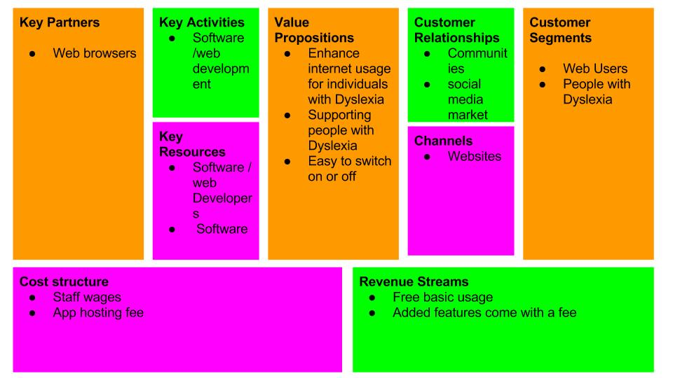

Adrians

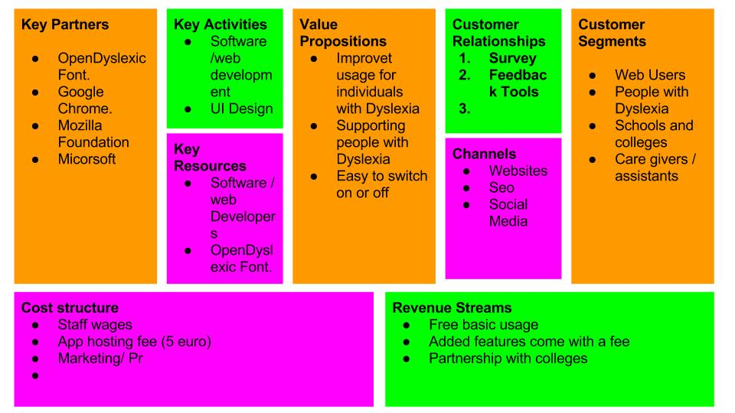

Robs

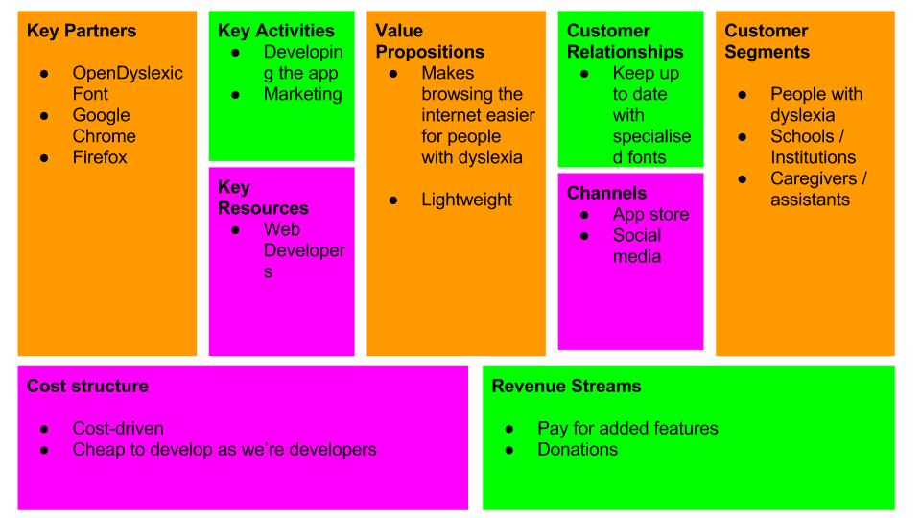

Michael

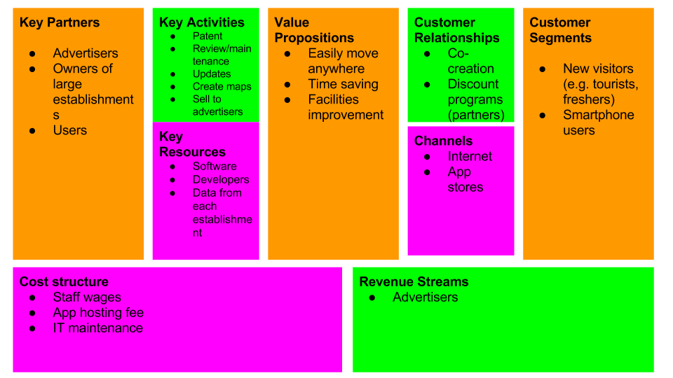

Karoline

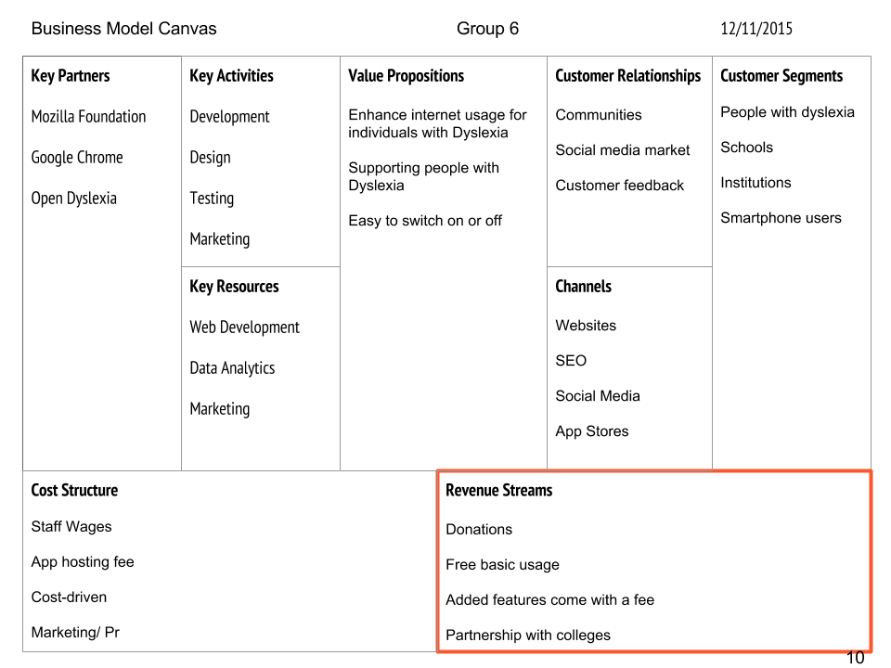

## Idea criteria checklist

### Idea: Auto Defroster

|  |  |
| --- | --- |
| **Criteria description** | **Ranking** |
| **Uniqueness of Idea** - Is it possible to patent? |  |
| **Potential of commercialisation** - How big is the target market, will they pay for it? |  |
| **Degree of manufacturing** - how difficult is it to produce, what are the costs to prototype/ manufacture? |  |
| **Idea Justification** - What problems does the product solve and how big is the problem? |  |
| **Year round or seasonal demand** - Will the product/ service be used throughout the year or is it only used seasonally? |  |
| **Sustainability of the idea** - Is the product long lasting? Will the need for the product stay or is it a trend? |  |
| **Scalability of the idea** - Can the idea lead to expansion? |  |
| **Competition** - What competition exists in the market? Who are the competitors? |  |
| **Resource availability** - Is the idea technically do-able? Do we have the competencies and tools? Can the necessary resources be obtained easily? |  |
| **Final Score :** |  |

## 

### Helper Bird Dyslexia App

|  |  |
| --- | --- |
| **Criteria description** | **Ranking** |
| **Uniqueness of Idea** - Is it possible to patent? | 7 |
| **Potential of commercialisation** - How big is the target market, will they pay for it? | 9 |
| **Degree of manufacturing** - how difficult is it to produce, what are the costs to prototype/ manufacture? | 2 |
| **Idea Justification** - What problems does the product solve and how big is the problem? | 9 |
| **Year round or seasonal demand** - Will the product/ service be used throughout the year or is it only used seasonally? | 10 |
| **Sustainability of the idea** - Is the product long lasting? Will the need for the product stay or is it a trend? | 9 |
| **Scalability of the idea** - Can the idea lead to expansion? | 8 |
| **Competition** - What competition exists in the market? Who are the competitors? | 8 Opendexic app |
| **Resource availability** - Is the idea technically do-able? Do we have the competencies and tools? Can the necessary resources be obtained easily? | 10, using javascript and html and google chrome |
| Final Score : | 87 |

## 

### Yik Yak Meets Notes sharing

|  |  |
| --- | --- |
| **Criteria description** | **Ranking** |
| **Uniqueness of Idea** - Is it possible to patent? | 4 |
| **Potential of commercialisation** - How big is the target market, will they pay for it? | 5 |
| **Degree of manufacturing** - how difficult is it to produce, what are the costs to prototype/ manufacture? | 4 |
| **Idea Justification** - What problems does the product solve and how big is the problem? | 5, none if i'm honest but always for anonymous sharing. |
| **Year round or seasonal demand** - Will the product/ service be used throughout the year or is it only used seasonally? | 5 |
| **Sustainability of the idea** - Is the product long lasting? Will the need for the product stay or is it a trend? | 5 a trend |
| **Scalability of the idea** - Can the idea lead to expansion? | 1 , none if im honest |
| **Competition** - What competition exists in the market? Who are the competitors? | 9None |
| **Resource availability** - Is the idea technically do-able? Do we have the competencies and tools? Can the necessary resources be obtained easily? | 10, developement tools are free and the rescouces are great/ |
| **Final Score :** | 48 |

### 

### Idea: Music Collaboration App

|  |  |
| --- | --- |
| **Criteria description** | **Ranking** |
| **Uniqueness of Idea** - Is it possible to patent? | 6 - There are other similar sites but for different mediums. |
| **Potential of commercialisation** - How big is the target market, will they pay for it? | 3 - Hard to commercialise as users could use other free sites instead. |
| **Degree of manufacturing** - how difficult is it to produce, what are the costs to prototype/ manufacture? | 7 - Could develop it ourselves, just have to pay for servers. |
| **Idea Justification** - What problems does the product solve and how big is the problem? | 6 - Makes it easier and cheaper for musicians to get a specific instrument featured in a track. |
| **Year round or seasonal demand** - Will the product/ service be used throughout the year or is it only used seasonally? | 10 |
| **Sustainability of the idea** - Is the product long lasting? Will the need for the product stay or is it a trend? | 8 |
| **Scalability of the idea** - Can the idea lead to expansion? | 5 - Besides adding smaller features the app only has one specific purpose. |
| **Competition** - What competition exists in the market? Who are the competitors? | 6 - Various other sites for art or people could just collaborate on social media. |
| **Resource availability** - Is the idea technically do-able? Do we have the competencies and tools? Can the necessary resources be obtained easily? | 8 - Simple enough to develop. |
| **Final Score :** | 59 |

## 

### W.A.I. (Where am I)

|  |  |
| --- | --- |
| **Criteria description** | **Ranking** |
| **Uniqueness of Idea** - Is it possible to patent? | 8 |
| **Potential of commercialisation** - How big is the target market, will they pay for it? | 8 |
| **Degree of manufacturing** - how difficult is it to produce, what are the costs to prototype/ manufacture? | 4 |
| **Idea Justification** - What problems does the product solve and how big is the problem? | 4 |
| **Year round or seasonal demand** - Will the product/ service be used throughout the year or is it only used seasonally? | 10 |
| **Sustainability of the idea** - Is the product long lasting? Will the need for the product stay or is it a trend? | 5 |
| **Scalability of the idea** - Can the idea lead to expansion? | 9 |
| **Competition** - What competition exists in the market? Who are the competitors? | 0 |
| **Resource availability** - Is the idea technically do-able? Do we have the competencies and tools? Can the necessary resources be obtained easily? | 10 |
| Final Score : | 58 |

## 